Pizza Sales SQL queries

* **KPIS**

1. Total Revenue

select sum(total_price) as total_revenue from sales;

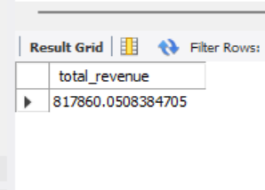

1. Total Orders

select count(distinct order_id) as Total_Orders from sales;

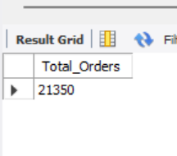

1. Average Order Value

select sum(total_price) / count(distinct order_id) as avg_order_value from sales;

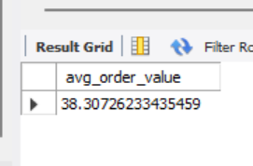

1. Total Pizza Sold

select sum(quantity) as Total_Pizza_sold from sales;

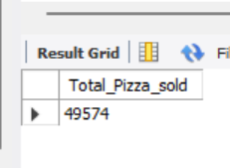

1. Average Pizza Sold per Order

select sum(quantity) / count(distinct order_id) as avg_pizza_sold from sales;

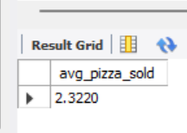

* **Charts**

1. Daily Trend for Total Orders

select dayname(order_date) as order_day, count(distinct order_id) as Total_Orders

from sales

group by dayname(order_date);

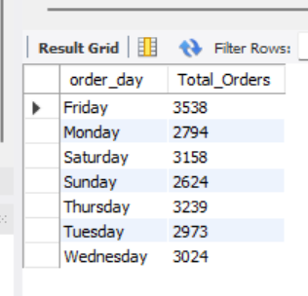

1. Hourly Trend

select hour(order_time) as order_hour, count(distinct order_id) as Total_Orders

from sales

group by hour(order_time);

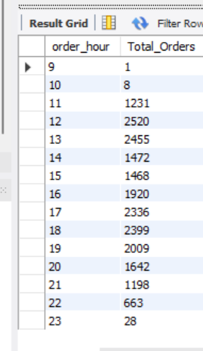

1. Percentage of sales by pizza category

select pizza_category, sum(total_price) * 100 / (select sum(total_price) from sales) as pct_pizza_category

from sales

group by pizza_category;

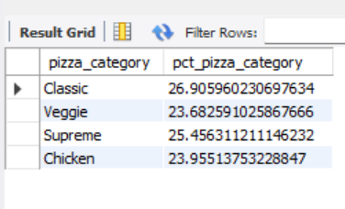

1. Percentage of sales by pizza size

select pizza_size, round(sum(total_price) * 100 / (select sum(total_price) from sales),4) as pct_pizza_size

from sales

group by pizza_size

order by pct_pizza_size desc;

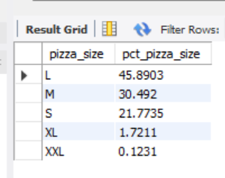

1. Total pizzas sold by pizza category

select pizza_category, sum(quantity) as Total_pizza_Sold_Category

from sales

group by pizza_category;

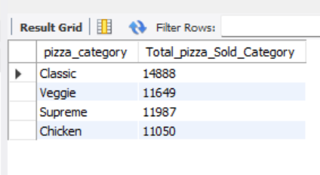

1. Top 5 Best Sellers by Total pizzas sold

select pizza_name, sum(quantity) as Total_Pizza_Sold

from sales

group by pizza_name

order by Total_Pizza_Sold desc

limit 5;

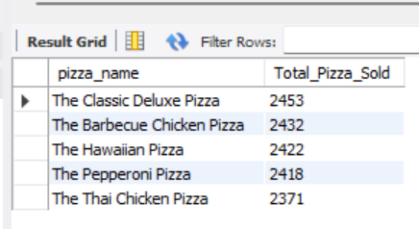

1. Bottom 5 Worst Sellers by Total pizzas sold

select pizza_name, sum(quantity) as Total_Pizza_Sold

from sales

group by pizza_name

order by Total_Pizza_Sold

limit 5;

